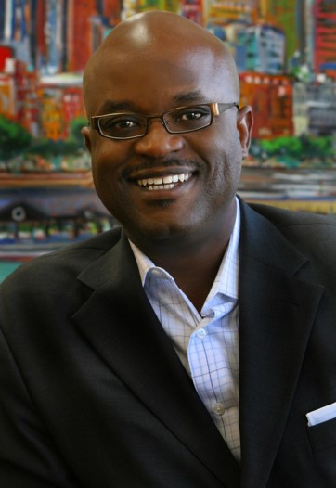

Alfonzo Alexander

A popular speaker on college campuses and corporate training rooms across the country, Alfonzo Alexander delivers powerful messages on leadership, strategy, business development and career growth. Through his experience as a corporate executive, non-profit leader and entrepreneur, Mr. Alexander relates to audiences at all levels, as he shares practical examples of how successful leaders have applied simple, but effective approaches to excel in their fields.

Alexander describes his style as one that gives a vision of “How to Achieve and Sustain Success” that is applicable in all business endeavors, careers and life. Using real-life stories, memorable techniques and fun, Alexander makes a lasting impact on his audiences. Here are a few things others have said about him.

“We had a great event, and an even greater speaker, Alfonzo Alexander.”
-A. Weaver, University of Utah Student

"Alfonzo, your Career Decision-Making Workshop was great. Your presentation helped me focus on the things I need to do make sure my business is headed in the best direction. Thank you for the positive impact you have made on my life and my son's life."
-R. Jasmin, President, Metropolitan Services

“Mr. Alexander, thank you for sharing with the students at Loyola University yesterday. I can honestly say that I had an insightful time during your presentation, and until today, I still could not stop sharing with my family and friends the information you presented to us.”
–K. Talapain, Loyola University Student

"Mr. Alexander, thank you so much for your informative session on interviewing. I went to an interview at my new company yesterday with confidence and won the job immediately. Keep touching lives by offering your knowledge. Again, I say thank you. "
-B. Angela, Caterpillar

"Alfonzo Alexander has helped me take my management skills to the next level. Whether it's been planning my next career move or learning how to survive organizational realignments, his advice has always been on target."
-Y. Darville, Communications and Writing Consultant

Alfonzo Alexander teaches real-world knowledge that provided me with up-to-the-minute, relevant information. He does professional development and training in an energetic and enlightening format. This was a valuable learning experience for me! Thank you.”
-C. Phoenix, VP of Community Relations, Revel Entertainment

"Alfonzo is a dynamic coach, presenter, and listener. He demonstrates a genuine interest in helping you be the best you can be through easy and active engagement, and creative problem-solving. He is a jewel."
-P. Merritt, Chief Talent Officer, Tricor

